Ramadan Prompting

Nights
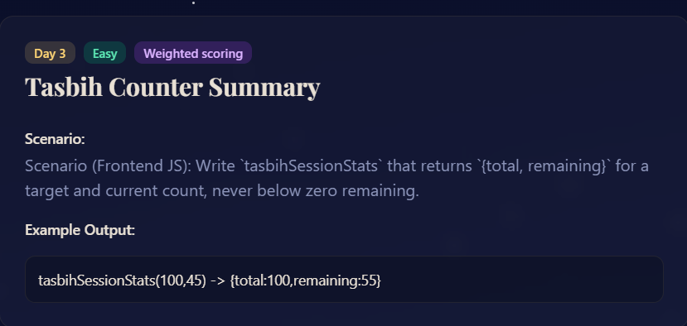
Scenario-based prompting competition. 30 nights. 30 real-world coding scenarios.
by Sir Asharib Ali · for GIAIC Students

PROMPT:
Goal: Write a JavaScript function tasbihSessionStats(target, current) that returns an object with total as the target count and remaining as the difference between target and current count. Ensure that remaining is never negative.
Constraints:
1. Target and current are integers ≥ 0.
2. remaining must be ≥ 0 even if exceeds target.
3. The function should always return an object with exactly two properties: total and remaining.
Edge Cases:
1. Current is 0 -> remaining equals target.
2. current equals target -> remaining is 0.
3. current exceeds target -> remaining is 0.
4. target is 0 -> remaining is 0 regardless of currents.
Output Format:
Return an object:

{
total: <target>
remaining: <target - current, never below 0>
}

Example:
tasbihSessionStats(100, 45) // {total: 100, remaining: 55}
tasbihSessionStats(50, 70) // {total: 50, remaining: 0}
tasbihSessionStats(0,10) // {total: 0, remaining: 0}
300, 600, 900, 1100]) // returns 0

